**Lesson 6 Demo 3**

**Set up Hyperledger Test Network**

|  |
| --- |
| **Objective:** To set up the Hyperledger Fabric test network in our machine  **Tools required:** Ubuntu, Terminal, Hyperledger  **Prerequisites:** None |

Steps to be followed:

1. Setting up the standard Hyperledger test network (Optional)
2. Setting up a test network with CA containers (Optional)
3. Setting up a test network with CouchDB containers (Optional)
4. Setting up a test network with all the above parameters

**Step 1: Setting up the standard Hyperledger test network**

1. Navigate to the **test-network** folder by using the following command:

***cd fabric-samples/test-network***

1. We may start the test network by executing the following command:

***sudo ./network.sh up***

1. We can also check the Docker images running the peers in our test network by executing the following command:

***sudo docker ps***

1. We can check the communication channel for this test network by executing the following command:

***docker exec peer0.org1.example.com peer channel list***

|  |
| --- |
| **Note:** Since there are no active channels, an empty list is displayed. |

1. We will create a communication channel for the peers in the test network using the following command:

***sudo ./network.sh createChannel -c testchannel***

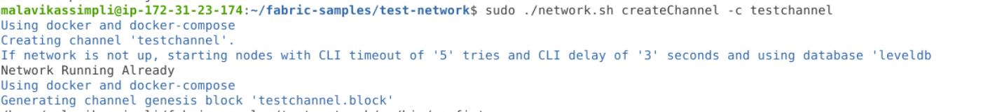

|  |
| --- |
| **Note:** The **-c** parameter allows us to name the channel. In this case, it is **testchannel**. |

1. Now if we check for the communication channel again, we will see the channel created



1. After we are done experimenting with the test network, we must turn it off using the following command:

***sudo ./network.sh down***

**Step 2: Setting up a test network with CA containers**

1. We may start a test network with CA containers using the following command:

***sudo ./network.sh up -ca***

1. We can create a communication channel for this network by executing the following command:

***sudo ./network.sh createChannel -c testchannel1***

1. We may confirm the creation of a test channel using the following command:

***docker exec peer0.org1.example.com peer channel list***



|  |
| --- |
| **Note:** The commands to check Docker containers, create a communication channel, and turn off the network remain the same (as shown in **Step 1**) across all the other steps. |

**Step 3: Setting up a test network with CouchDB containers**

1. We may start a test network with CouchDB containers using the following command:

***sudo ./network.sh up -s couchdb***

1. We can create a communication channel for this network by executing the following command:

***sudo ./network.sh createChannel -c testchannel2***

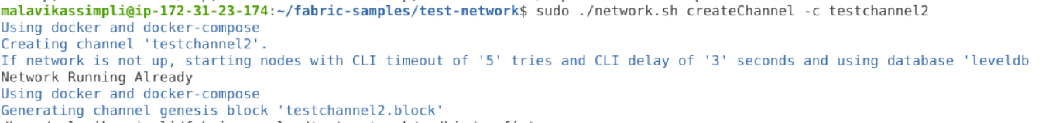

1. We can turn off the network after our testing using the following command:

***sudo ./network.sh down***

**Step 4: Setting up a test network with all the above parameters**

1. We may start a test network with all the above parameters and containers using the following command:

First, go to fabric-samples/test-network folder

***sudo ./network.sh up -ca -s couchdb***

1. We can create a communication channel for this network by executing the following command:

***sudo ./network.sh createChannel -c mychannel***

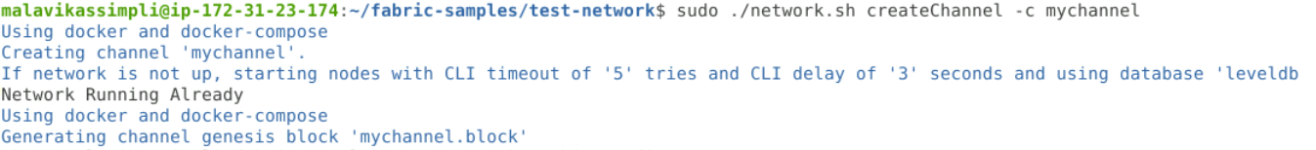

Run the below command to provide required access to the folder structure:

sudo chmod -R 777 .

1. We can turn off the network after our testing using the following command:

***sudo ./network.sh down***

|  |
| --- |
| The setup of the Hyperledger Fabric test network on the machine is complete. |